UniEats

Phase 2

Team 8
Member Name | Member Roll # | Primary Responsibility
Sikander Atif | 22i-0896 | Use case Diagram Formation
M Massab | 22i-0958 | Use cases Documentation
Abdul Mannan Faraz | 22L-6841 | Analysis Diagram Formation
Muhammad Salman Amir | 22L-6830 | Use case Functional Requirements Analyzation
Masab bin Wisal | 22L-6709 | Use cases Documentation

Table of Contents
Table of Contents iii
1. UseCase Diagram 3
2. UseCase Description 4
3. UML Diagram 18

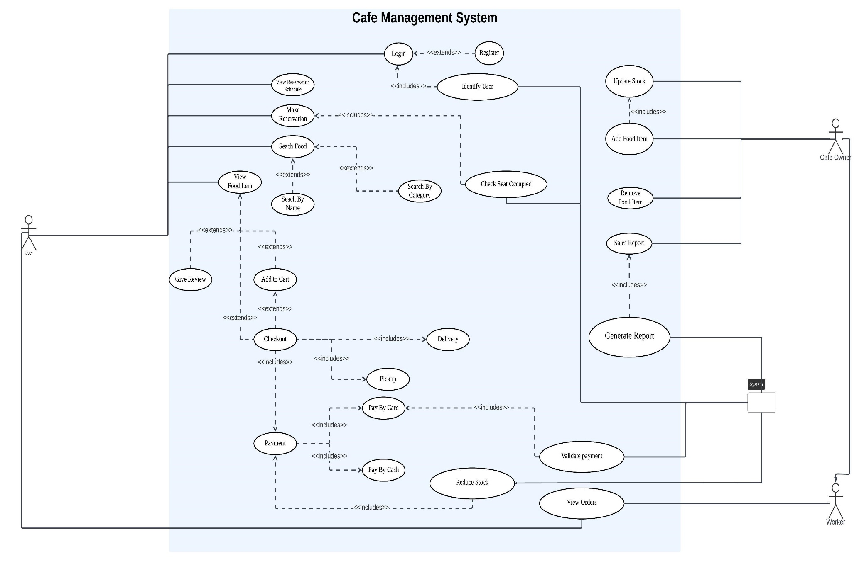

Identifier |  | UC-01
Name |  | Identify User
Summary |  | Identifies user via login details
Priority |  | High
Actors |  | System
Pre-condition(s) |  | Null
Post-condition(s) |  | Null
Typical Course of Action
S# | Actor Action |  | System Response
1. | Opens app.
2. |  |  | Identifies User from saved login details.
3. |  |  | Opens home page.
Alternate Course of Action
S# | Actor Action |  | System Response
2. |  |  | Moves user to login page (login details not saved).

Identifier |  | UC-02
Name |  | Login
Summary |  | Asks login details to identify user
Priority |  | High
Actors |  | User
Pre-condition(s) |  | Actor is Registered
Post-condition(s) |  | Null
Typical Course of Action
S# | Actor Action |  | System Response
1. | Opens App.
2. |  |  | System fails to identify user.
3. |  |  | Displays login page.
4. | User enters login info.
5. |  |  | Verifies login details.
6. |  |  | Displays Home Page.
Alternate Course of Action
S# | Actor Action |  | System Response
6. |  |  | Asks User to re-enter details or register if not already.
7. | Enters details.
8. |  |  | (5)<continue from S# 5>

Identifier |  | UC-03
Name |  | Register
Summary |  | Registers new users into database.
Priority |  | High
Actors |  | User
Pre-condition(s) |  | User should not have account.
Post-condition(s) |  | Null
Typical Course of Action
S# | Actor Action |  | System Response
1. | User presses Register button.
2. |  |  | Displays the register page.
3. | User enters required details.
4. | Presses Register Button.
5. |  |  | Verifies details provided.
6. |  |  | Creates an account.
Alternate Course of Action
S# | Actor Action |  | System Response
6. |  |  | Asks user to re-enter details.
7. | Enter details.
8. |  |  | (5)<continue from S# 5>

Identifier |  | UC-04
Name |  | View Reservation Schedule
Summary |  | User can view reservation schedule to see available seats at specific times
Priority |  | High
Actors |  | User, System
Pre-condition(s) |  | User is logged in.
Post-condition(s) |  | Null
Typical Course of Action
S# | Actor Action |  | System Response
1. | User clicks on schedule button.
2. |  |  | Displays reservation schedule of the day for all time intervals.
Alternate Course of Action
S# | Actor Action |  | System Response

Identifier |  | UC-05
Name |  | Make Reservation
Summary |  | User can request a reservation for a specific seat at a specific time interval.
Priority |  | High
Actors |  | User, System
Pre-condition(s) |  | User is logged in.
Post-condition(s) |  | Null
Typical Course of Action
S# | Actor Action |  | System Response
1. | User selects an unoccupied seat at time interval of his choosing.
2. | User presses the reserve button.
3. |  |  | Seat is reserved using the users details.
Alternate Course of Action
S# | Actor Action |  | System Response
1. | User selects an occupied seat.
2. | User presses the reserve button.
3. |  |  | User is told to select an unoccupied seat.

Identifier |  | UC-06
Name |  | Check Seat Occupied
Summary |  | System constantly updates the reservation schedule to update any seats that have been reserved.
Priority |  | High
Actors |  | System
Pre-condition(s) |  | Null
Post-condition(s) |  | Null
Typical Course of Action
S# | Actor Action |  | System Response
1. |  |  | Waits for reservation
2. |  |  | Updates seat status to occupied in real time when reservation made.
3. |  |  | Repeat Step 1
Alternate Course of Action
S# | Actor Action |  | System Response

Identifier |  | UC-07
Name |  | Search Food
Summary |  | User Can Search Different Food Items
Priority |  | Med
Actors |  | User
Pre-condition(s) |  | User is logged in
Post-condition(s) |  | Null
Typical Course of Action
S# | Actor Action |  | System Response
1. | User presses on Food Button.
2. |  |  | Displays Food Page.
3. | User can browse different food items.
Alternate Course of Action
S# | Actor Action |  | System Response

Identifier |  | UC-08
Name |  | Search By Name
Summary |  | User can search specific food item by inserting name in search bar.
Priority |  | Low
Actors |  | User
Pre-condition(s) |  | User is in Food Page.
Post-condition(s) |  | Null
Typical Course of Action
S# | Actor Action |  | System Response
1. | User presses on search bar.
2. | User inserts name of food item.
3. |  |  | Displays relevant items.
Alternate Course of Action
S# | Actor Action |  | System Response

Identifier |  | UC-09
Name |  | Search By Category
Summary |  | User can search food items by selecting category from slider
Priority |  | Low
Actors |  | User
Pre-condition(s) |  | User is in Food Page
Post-condition(s) |  | Null
Typical Course of Action
S# | Actor Action |  | System Response
1. | User presses on categories of his choice from slider.
2. |  |  | Displays food items of relevant category.
Alternate Course of Action
S# | Actor Action |  | System Response

Identifier |  | UC-10
Name |  | View Food Item
Summary |  | Allows User to view details, price, availability and reviews about a specific food item
Priority |  | Med
Actors |  | User
Pre-condition(s) |  | User is in Food Page.
Post-condition(s) |  | Null
Typical Course of Action
S# | Actor Action |  | System Response
1. | User Presses on Food Item.
2. |  |  | Displays details of Food Item along with price, availability and any reviews.
Alternate Course of Action
S# | Actor Action |  | System Response

Identifier |  | UC-11
Name |  | Give Review
Summary |  | User can give review of item.
Priority |  | Med
Actors |  | User
Pre-condition(s) |  | User is viewing a food item
Post-condition(s) |  | Null
Typical Course of Action
S# | Actor Action |  | System Response
1. | User presses on review button beneath details of item.
2. | Writes and Submits review.
3. |  |  | Uploads review in system database.
Alternate Course of Action
S# | Actor Action |  | System Response

Identifier |  | UC-12
Name |  | Add to Cart
Summary |  | Adds an Item to Cart
Priority |  | High
Actors |  | User
Pre-condition(s) |  | User is viewing an item.
Post-condition(s) |  | Null.
Typical Course of Action
S# | Actor Action |  | System Response
1. | User selects quantity of specific item.
2. | User presses Add to Cart.
3. |  |  | Adds items to Cart.
4. |  |  | Asks User if they wish to want to place order.
Alternate Course of Action
S# | Actor Action |  | System Response

Identifier |  | UC-13
Name |  | Checkout
Summary |  | User can Checkout.
Priority |  | High
Actors |  | User
Pre-condition(s) |  | User selects quantity of items.
Post-condition(s) |  | Payment and Delivery or Pickup
Typical Course of Action
S# | Actor Action |  | System Response
1. | Presses on Checkout.
2. |  |  | Calculates total bill and Proceeds to checkout page.
3. |  |  | Asks for Delivery and Payment options.
Alternate Course of Action
S# | Actor Action |  | System Response

Identifier |  | UC-14
Name |  | Payment
Summary |  | User chooses payment option.
Priority |  | High
Actors |  | User
Pre-condition(s) |  | User places order and proceeds to checkout page.
Post-condition(s) |  | Pay By Card or Pay By Cash
Typical Course of Action
S# | Actor Action |  | System Response
1. | User presses Pay By Card.
Alternate Course of Action
S# | Actor Action |  | System Response
1. | User Presses Pay By Cash.

Identifier |  | UC-15
Name |  | Pay By Card
Summary |  | User enters card details (if not already saved)
Priority |  | High
Actors |  | User
Pre-condition(s) |  | User selects Pay By Card as Payment option and delivery address added (if not pickup).
Post-condition(s) |  | Validate Payment
Typical Course of Action
S# | Actor Action |  | System Response
1. | User enters card details.
2. |  |  | Verifies details validity.
3. |  |  | Asks to confirm payment.
4. | Confirms Payment
5. |  |  | Transaction complete.
6. |  |  | Displays Receipt.
7. |  |  | Return to Home Page.
Alternate Course of Action
S# | Actor Action |  | System Response
3. |  |  | Asks user to re-enter details.
4. | User re-enters details.
5. |  |  | (2)<continue from S# 2>
Alternate Course of Action 2
S# | Actor Action |  | System Response
4. | Denies Payment.
5. |  |  | Returns to Checkout Page.

Identifier |  | UC-16
Name |  | Validate Payment
Summary |  | Validates Payment for Pay By Card
Priority |  | High
Actors |  | System
Pre-condition(s) |  | User enters valid card details and confirms payment
Post-condition(s) |  | Null
Typical Course of Action
S# | Actor Action |  | System Response
1. | Confirms payment after validation of card details.
2. |  |  | Validates Payment.
3. |  |  | Return Receipt to User.
Alternate Course of Action
S# | Actor Action |  | System Response
3. |  |  | Informs User of error during transaction.
4. |  |  | Returns to Card Details Page.

Identifier |  | UC-17
Name |  | Pay By Cash
Summary |  | System informs café of payment through cash
Priority |  | High
Actors |  | User
Pre-condition(s) |  | User selects Pay By Cash Payment Option
Post-condition(s) |  | Null
Typical Course of Action
S# | Actor Action |  | System Response
1. | User presses Pay By Card and Proceed.
2. |  |  | Informs Café of Payment through cash.
Alternate Course of Action
S# | Actor Action |  | System Response

Identifier |  | UC-18
Name |  | Reduce Stock
Summary |  | Reduces Stock after Order has been placed
Priority |  | High
Actors |  | System
Pre-condition(s) |  | Successful placement of order
Post-condition(s) |  | Null
Typical Course of Action
S# | Actor Action |  | System Response
1. |  |  | Reduces total stock by amount placed in order.
Alternate Course of Action
S# | Actor Action |  | System Response

Identifier |  | UC-19
Name |  | View Orders
Summary |  | Can view Orders Placed
Priority |  | High
Actors |  | Users, worker, owner
Pre-condition(s) |  | Logged in
Post-condition(s) |  | Null
Typical Course of Action
S# | Actor Action |  | System Response
1. | Presses orders button.
2. |  |  | Displays Orders Page.
Alternate Course of Action
S# | Actor Action |  | System Response

Identifier |  | UC-20
Name |  | Pickup
Summary |  | User will pickup his order
Priority |  | Med
Actors |  | User
Pre-condition(s) |  | User select pickup as delivery method.
Post-condition(s) |  | Payment
Typical Course of Action
S# | Actor Action |  | System Response
1. | User presses pickup as delivery method.
2. |  |  | Informs café of user order pickup.
Alternate Course of Action
S# | Actor Action |  | System Response

Identifier |  | UC-21
Name |  | Delivery
Summary |  | Enter Seat No.
Priority |  | High
Actors |  | User
Pre-condition(s) |  | User Selects Delivery as delivery method.
Post-condition(s) |  | Payment
Typical Course of Action
S# | Actor Action |  | System Response
1. | User Enters Seat No.
2. |  |  | Validates Seat No.
Alternate Course of Action
S# | Actor Action |  | System Response
1. |  |  | Asks User to enter valid Seat No.
2. | Re-enters Seat No.

Identifier |  | UC-22
Name |  | Update Stock
Summary |  | Owner adds/removes stock
Priority |  | High
Actors |  | Café Owner
Pre-condition(s) |  | Logged in
Post-condition(s) |  | Null
Typical Course of Action
S# | Actor Action |  | System Response
1. | Adds/Removes stock.
2. |  |  | Updates Stock accordingly.
Alternate Course of Action
S# | Actor Action |  | System Response

Identifier |  | UC-23
Name |  | Add Food Item
Summary |  | Owner Adds new food Items
Priority |  | High
Actors |  | Café Owner
Pre-condition(s) |  | Logged in
Post-condition(s) |  | Update Stock
Typical Course of Action
S# | Actor Action |  | System Response
1. | Adds New Food Item name.
2. | Add Item Image (if any).
3. | Presses Add Item Button.
4. |  |  | Proceeds to update stock page.
Alternate Course of Action
S# | Actor Action |  | System Response

Identifier |  | UC-24
Name |  | Remove Food Item
Summary |  | Owner Removes any existing food Item
Priority |  | High
Actors |  | Café Owner
Pre-condition(s) |  | Item Exists
Post-condition(s) |  | Null
Typical Course of Action
S# | Actor Action |  | System Response
1. | Selects which Item to remove.
2. |  |  | Removes Item.
Alternate Course of Action
S# | Actor Action |  | System Response

Identifier |  | UC-25
Name |  | Sales Report
Summary |  | Owner can view sales of current and previous days/months/years.
Priority |  | High
Actors |  | Café Owner
Pre-condition(s) |  | Logged in.
Post-condition(s) |  | Null
Typical Course of Action
S# | Actor Action |  | System Response
1. | Selects timeframe of sales to display.
2. |  |  | Generates Report.
3. |  |  | Displays Report.
Alternate Course of Action
S# | Actor Action |  | System Response

Identifier |  | UC-26
Name |  | Generate Report
Summary |  | Calculate and Generates Sales Report requested by owner.
Priority |  | High
Actors |  | System
Pre-condition(s) |  | User Requests Sales Report
Post-condition(s) |  | Null
Typical Course of Action
S# | Actor Action |  | System Response
1. | Requests sales report.
2. |  |  | Calculates Sales.
3. |  |  | Generates Report.
Alternate Course of Action
S# | Actor Action |  | System Response

